Exercise: Evading growth suppressors
1) Concepts:
a) Heterozygous heritable mutations in tumor suppressors can predispose entire families to an increased cancer risk. Why does not every family member always develop cancer?
b) Restoring a growth suppressor that was deleted is even more difficult than inhibiting a factor such as EGFR or KRAS that acquire gain-of-function mutations to become oncogenic. What therapeutic strategies might still be worth considering:
- if a tumor suppressor has been deleted?
- if a tumor suppressor has been silenced epigenetically (e.g. by promoter methylation, or by upregulation of specific miRNAs)?
- if a tumor suppressor is inactivated by opposing signals (e.g. Akt Mdm2 –I p53)?
- What complications would you predict to arise from drug treatments that target MDM2 (s. slide 33)?
- Other drugs under development seek to restore tumor-suppressive activity of mutant p53 protein, or increase its degradation (slide 35). What advantages or risks/disadvantages would you predict for either of these approaches?

2) Former exam MCQ: Tumor suppression can be compromised by any of the following, except:
- by mutations in SMAD2 or SMAD3.
- binding of SMAD2 or SMAD3 to SMAD4.
- Hyperphosphorylation of the retinoblastoma protein RB1.
- Loss of heterozygosity of APC.
- mutations in the TGF-beta receptor type II.

3) Reasoning, deduction:
Knudson's 2-hit hypothesis states that both alleles of a tumor suppressor gene (TSG) must be mutated to disrupt its protective function. Mouse Rb1 (also known as pRb) and the human homolog RB1 fulfill this prediction. However, there are important exceptions: For some TSGs, haploidy reduces the dosage of the corresponding protein beyond a critical level that is needed for proper functioning. Such a gene is called "haploinsufficient" and the resulting phenomenon is "haploinsufficiency". In some cases, mutations can even have "dominant negative" effects if the mutant protein blocks the residual wild-type form in heterozygous cells.
a) Considering what is known about p53 feedback regulationby MDM2, do you expect p53 deletions to be haploinsufficient? Why or why not?

b) 96% of the p53 mutant cancers delete one copy of p53 whereas the other acquires a point mutation. Should we expect these point mutants to act as dominant negatives? Why or why not?

4) Data interpretation & testing hypotheses
Background information: Mammals have three TGFβ genes (isoforms 1, 2 and 3) that signal through the same receptors, but most cancer research has been conducted on TGF-β1. Epithelial cells store secreted TGF-β1 in their extracellular matrix as a latent complex. Dissociation from an inhibitory prodomain in this latent complex is tightly regulated to control when and where the active form is released to bind and stimulate TGF-β receptors, e.g. to thereby inhibit the cell cycle. On the other hand, entry into the cell cycle requires specific proliferation signals, mediated e.g. by RTKs. In normal mammary glands, the production of important proliferation signals is governed by the hormones progesterone and estrogen and their “nuclear receptors” ER and PR that function as transcription factors upon arrival in the nucleus.

a b
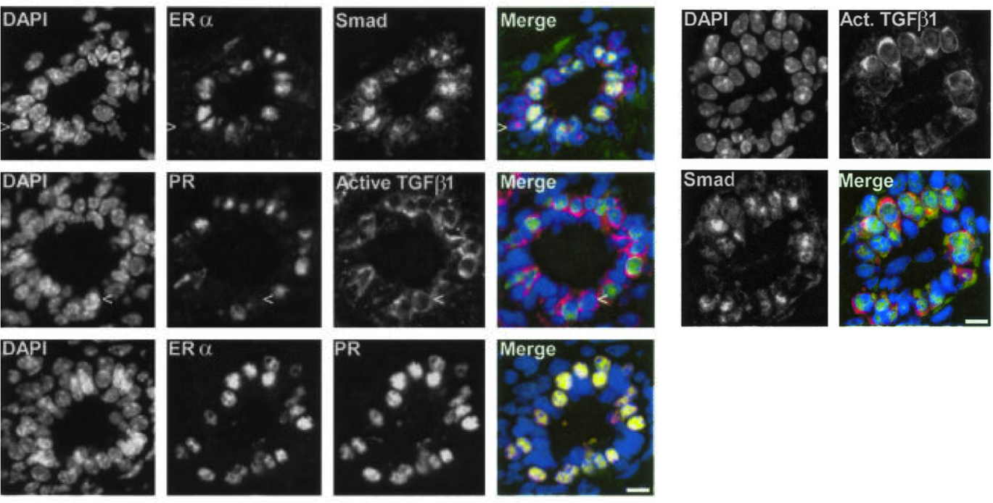
c d e
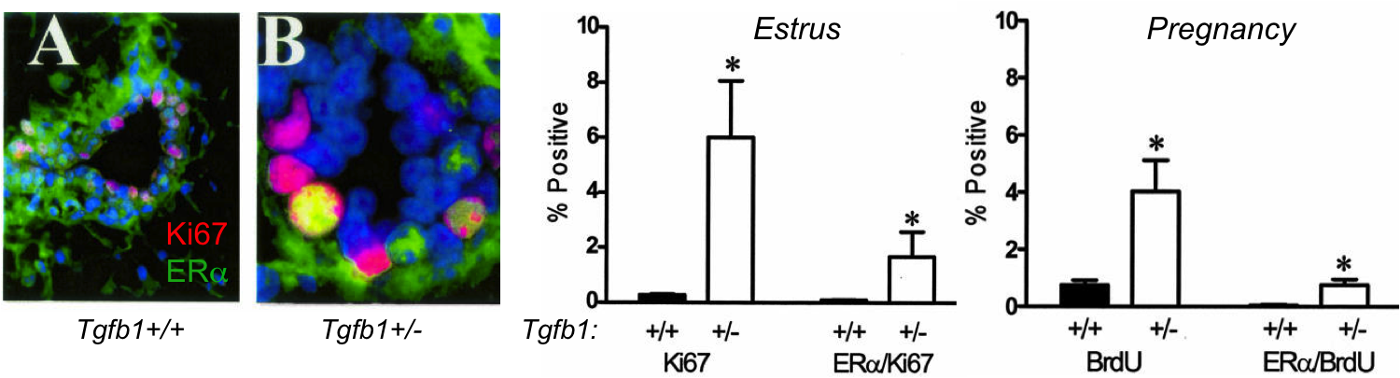
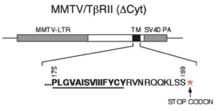
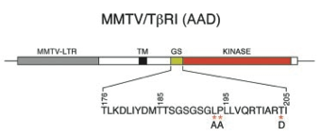
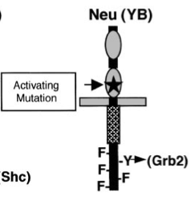
f
Truncated TβR2 (Δcyt)
(dominant negative)
Oncogenic mutant RTK (Neu)
Phosphomimicking mutant TβR1 (AAD), ligand-independent

Figure 1. TGF-β signaling in adult mouse mammary epithelium. a, b) Double immunostainings of the indicated proteins, superimposed to nuclear staining of DNA by DAPI in transverse sections through mammary ducts. ERα: Estrogen receptor α; PR: progesterone receptor; Smad: Antibody that binds phosphorylated Smad2 and Smad3; Active TGF-β1: Antibody that stains the active growth factor. c) Co-immunostaining of ERα and Ki67, a marker of proliferating cells in S-phase. d) Quantification of Ki67 single positive and Ki67/ERα double positive mammary epithelial cells at the time of ovulation (Estrus). e) Quantification of ERα-negative and ERα-positive cells in S-phase, marked by incorporation of the thymidine analog BrdU during pregnancy. f) Transgenes introduced in mice to evaluate a tumor-suppressive role of TGF-β signaling in mammary epithelial cells.
a) Immunofluorescent labelling by antibodies that specifically bind active TGF-β1 but not the latent form stain only a subpopulation of cells in the mammary epithelium. What distinguishes these TGF-β1⁺ cells from their neighbors in the histological sections shown in figure 1a, b?

b) Some sections in figure 1a, b were stained by antibodies against phospho-Smad2&3 (p-Smad), together with anti-ERα or with anti-TGF-β. Based on what we discussed in the lecture (and considering that TGF-β is a secreted factor), which cells would you have predicted to stain positive for p-Smad?

How do the results in figure 1a, b compare to your prediction, and what does it reveal about which mammary epithelial cells might depend on TGF-β to limit their proliferation?

c) To evaluate the influence of impaired TGF-β signaling on cell proliferation, mouse mammary glands were stained for the S-phase markers Ki67 (Fig. 1c, d) or bromo-deoxyuridine (BrdU), a thymidine analog that can be injected into mice and stained after incorporation into DNA of dividing cells using anti-BrdU antibodies (Fig. 1e). What do these data reveal about the role of TGF-β signaling in mammary epithelial cells?

d) To test the role of TGF-β signaling in a breast cancer model, researchers crossed into MMTV-Neu transgenic tumor mice a second transgene encoding either C-terminally truncated TGF-β type II receptor (Δcyt), or AAD mutant TGF-β type I receptor where the threonine residue that is subject to phosphorylation by type II receptors was deliberately substituted by aspartic acid (D) to mimic the structure of phospho-threonine (Fig. 1f).
- How do you predict each of these mutant type II or type I receptors to alter endogenous TGF-β signaling strength?

- What experiment would you propose to quickly validate your predictions?

- Predict for each of these TGF-β receptor transgenes whether they will accelerate or slow the growth of MMTV::Neu-induced breast tumors.

